**Q. Simple Network configuration → Connect two PC through a Router, PC0 should be able to PC1 and vice-versa.**

**Steps:**

*#1. Add end devices and router and use connections to join them*

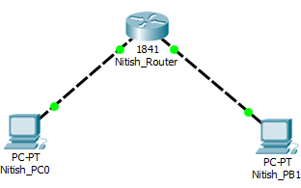

*#2. Add static gateway 192.168.10.10, ipadress 192.168.10.12, subnet mask 255.255.255.0 to PC0*

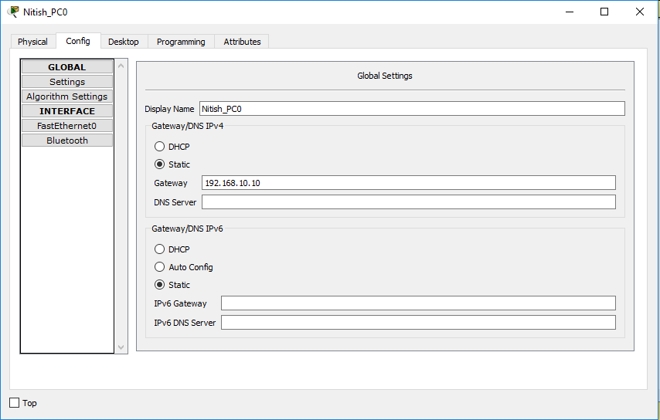

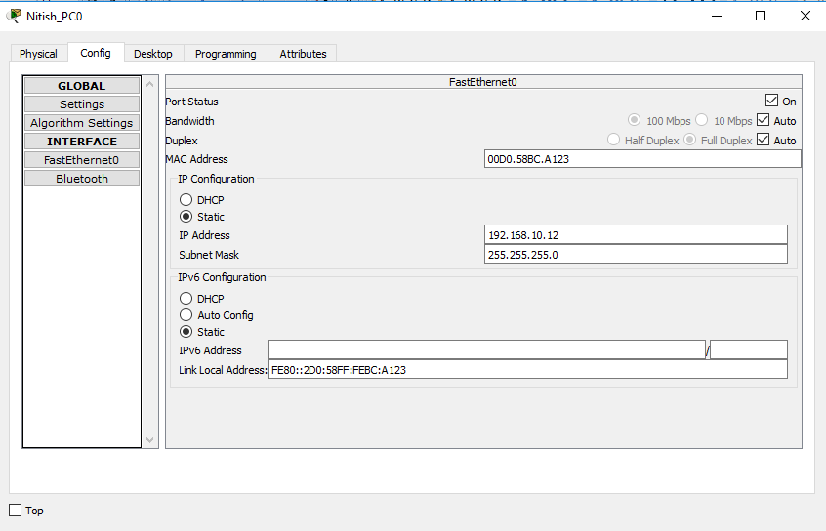

*#3. Add static gateway 192.168.12.12, ipadress 192.168.12.25, subnet mask 255.255.255.0 to PC1*

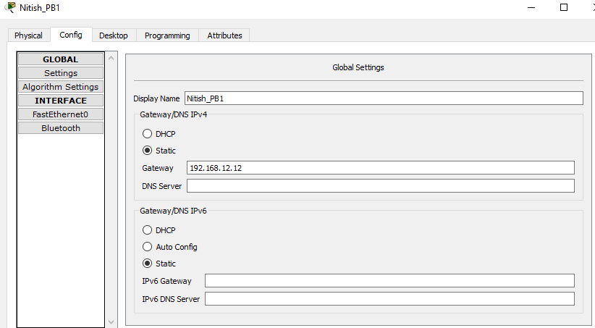

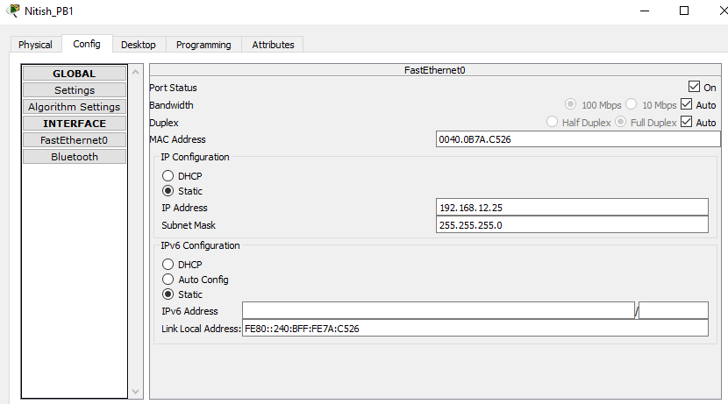

*#4. Configure the router set FastEthernet0/0 – IP Address=192.168.10.10(gateway of PC0), subnet mask 255.255.255.0 FastEthernet0/1 – IP Address=192.168.12.12(gateway of PC1), subnet mask 255.255.255.0*

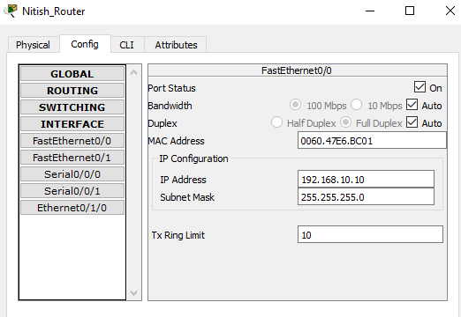

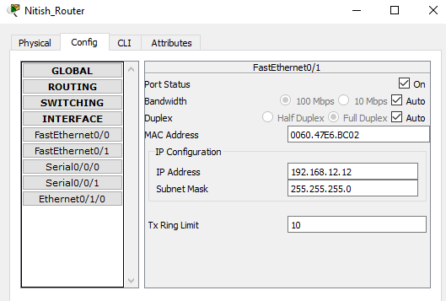

*#5.PING PC1 from PC0 and vice-versa to test connections*

